
Sandon Primary Academy

Application Form

Tel: 01782 319097
Email: info@sandonprimary.org.uk
Normacot Grange Road
Meir
Stoke-on-Trent
ST3 7AW

Details of Vacancy
Vacancy ID: |  |  |  |  |  |  |  |  |  |  |  |  |  |  |  | Closing Date: |  |  |  |  |  |  |  |  | Click here to enter a date.
Job Title:
Source: Please state where you saw this job advertised, if seen on the internet which site?
Personal Details
Title: | Ms☐ Miss☐ Mrs☐ Mr☐ Dr☐ |  |  |  |  |  |  |  |  |  |  |  |  |  | Surname: |  |  |  |  |  |  | Forename(s):
Preferred pronouns:
Address:
Post Code:
Tel No. Home: |  |  |  |  |  |  |  |  |  |  |  |  |  |  |  | Mobile:
Date of Birth: |  |  |  |  |  |  |  |  |  |  |  |  |  |  |  | NI Number:
Email:
Do you have a full driving licence? |  |  |  |  |  |  |  |  | Yes ☐ No ☐ |  |  |  |  |  |  | Do you have the ability to travel? |  |  |  |  |  |  |  |  |  |  |  |  | Yes ☐ No ☐
Education Secondary, Further and Higher
(a) Secondary
Subject |  |  |  |  |  |  |  |  |  | Specify GCSE, CSE, ‘O’ levels etc. |  |  |  |  |  |  | Grade Obtained/Expected |  |  |  |  |  |  |  | Name of School
(b) Further and Higher
Subject |  |  |  |  |  |  |  |  |  | Qualifications, specify ‘A’ level, N.V.Q, BSc etc. |  |  |  |  |  |  | Grade Obtained/Expected |  |  |  |  |  |  |  | Name of College/University
(c) Profession Qualification/Membership of Professional Body (inc Dfes)
Name of Professional Body/Association |  |  |  |  |  |  |  |  |  | Current Level of Membership |  |  |  |  |  |  | Method of Achievement (e.g. Application; examination; invitation) |  |  |  |  |  |  |  | Membership/Ref Number
Training / Development / Learning
Please list relevant training undertaken over the past five years (continue on a separate sheet if required)
Present/Last Employer (please delete as applicable)
Please give details of your present employment.

References must be provided
Job Title: |  |  |  |  |  |  |  |  |  |  |  |  | Salary/Grade: |  |  |  |  |  |  |  |  |  | Spinal Point:
Establishment Name:
Address: |  |  |  |  |  |  |  |  |  |  |  |  |  |  |  |  |  |  |  |  |  |  | Post Code:
Tel No:
Start Date:
Notice Period:
Summary of duties/responsibilities and skills/responsibilities required:
Reason for wanting to leave:
Employment History (Previous employers may be contacted to validate information provided) Provide most recent first.
Dates From |  | To |  |  |  |  |  | Name & Address of Employer |  |  |  |  |  | Job Title / Grade / Salary |  |  |  |  |  | Brief outline of the role of the job |  |  |  |  |  | Reason for leaving
Continue on a separate sheet if necessary, clearly indicating the Vacancy ID number
If there are any gaps in your employment or education please explain them below:
Support Information
This is the part of the form where you have a chance to tell us why you are suitable for the job. You need to give as much information as you can about your skills, abilities, knowledge and experience (continue on a separate sheet if necessary)
References
Please supply the names and contacts of at least two professional referees who can comment on your suitability for this position. One should be your current or most recent employer (N.B. If you are not currently working with children but have done so in the past the second referee should be the employer by whom you were most recently employed in work with children. References will not be accepted from relatives or persons who only know you as a friend).
Name: |  |  |  |  |  |  |  |  |  |  |  |  |  |  |  |  | Name:
Position: |  |  |  |  |  |  |  |  |  |  |  |  |  |  |  |  | Position:
In what capacity do you know the referee? |  |  |  |  |  |  |  |  |  |  |  |  |  |  |  |  | In what capacity do you know the referee?
Name of Organisation: |  |  |  |  |  |  |  |  |  |  |  |  |  |  |  |  | Name of Organisation:
Address: |  |  |  |  |  |  |  |  |  |  |  |  |  |  |  |  | Address:
Post Code: |  |  |  |  |  |  |  |  |  |  |  |  |  |  |  |  | Post Code:
Tel: |  |  |  |  |  |  |  |  |  |  |  |  |  |  |  |  | Tel:
Email: |  |  |  |  |  |  |  |  |  |  |  |  |  |  |  |  | Email:
Dates when you would NOT be able to attend interview:
(N.B Every effort will be made to avoid these dates but this may not always be possible)

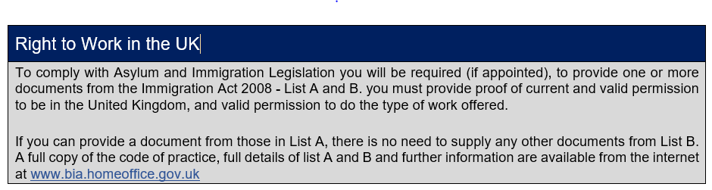

Vetting and Barring Scheme (VPS)
The Vetting and Barring Scheme was introduced under Safeguarding Vulnerable Groups Act 2006. Its core purpose is to be prevent unsuitable people from working with children and vulnerable adults by providing a registration system with continuous updating of their criminal history information.

If this post gives substantial opportunity for regulated work with children then it will be exempt from the Rehabilitation of Offenders Act 1974-the successful applicant will therefore be required to apply for an enhanced DBS certificate and it would be a criminal offence to apply for this post if you are included on the children’s barred list held by the DBS.

Amendments to the Expectations Order 2023 provide that certain spent convictions and cautions are ‘protected’ These are not subject to disclosure to employers and cannot be taken into account. Guidance and criteria on filtering of these cautions and convictions can be found on the Ministry of Justice website.

Shortlisted candidates will be asked to provide details of all unspent convictions and those that would not be filtered prior to the date of interview. You may be asked for further information about your criminal history during the recruitment process. If your application is successful this self-disclosure information will be checked against information from the disclosure and barring service before your appointment is confirmed.

Declaration
I declare that all the information I have provided is complete and accurate and I understand that any offer of employment is subject to:
- references which are satisfactory to the academy
- a satisfactory DBS certificate and check of the barred list (if appropriate for post)
- the entries on this form proving to be complete and accurate
- satisfactory medical report if appropriate

Signature: |  |  |  |  |  |  |  |  |  |  |  |  |  |  |  |  |  |  | Date:
The Recruitment Policy states that:

Candidates who have sibling links or related family links as students will also not be considered for vacant posts due to potential conflict of interest.

Online due diligence is part of the selection process.

I consent to online checks being carried out in line with safer recruitment.
Signature: |  |  |  |  |  |  |  |  |  |  |  |  |  |  |  |  |  |  | Date:

OUR CHILD PROTECTION & SAFEGUARDING POLICY CAN BE FOUND ON THE FOLLOWING LINK
https://www.sandonprimaryacademy.com/policies

